Contact: Sharon Esche or Alexander Irving
Esche & Alexander Public Relations
760-414-3370
sharon@beauty-pr.com
alex@beauty-pr.com

FOR IMMEDIATE RELEASE
View/Download Photo

GORDON LABORATORIES, INC. HOSTS
ICMAD 2016 YOUNG DESIGNER AWARDS WINNERS
AT CARSON, CA CORPORATE HQ & FACILITY

Gordon Laboratories Inc. (GLI) recently gave a tour of their Carson, CA contract manufacturing facility to the ICMAD 2016 'Young Designer Awards' Competition Winners. Gordon Laboratories CEO Greg Chambers, also a judge in the competition, reports that was he proud to be selected by ICMAD as one of the three companies invited to host the award winners at their headquarters before the Gala Awards Dinner on February 22nd at the Island Hotel Newport Beach, also attended by the Gordon management group.

According to Chambers: "We were honored to be a part of this year's ICMAD 'Young Designer Awards' events and activities. With knowledge of package design in my background, I really see the value of this annual national program that fosters student excellence in graphic and packaging design. Touring our facilities also offered these aspiring professionals a valuable insight into the field of personal care and the opportunities that lie within it for their future."

Gordon Laboratories, Inc. is a proud member of the Independent Cosmetic Manufacturers and Distributors Association (ICMAD) for over 20 years. GLI is a contract manufacturer and custom formulator for prestige skin, hair and body care, including natural and certified organic products.

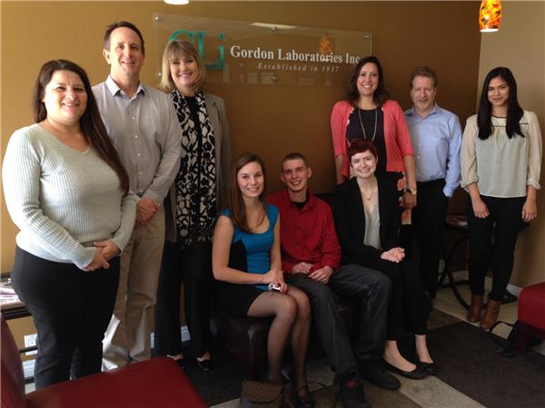
(Photo Caption)
Photo # 1 - click to view/download photo
Gordon Laboratories, Inc. executives recently hosted the ICMAD 2016 'Young Designer Awards' Competition Winners, giving them a tour of their contract manufacturing facility in Carson, CA. Left to right, Connie Rivas, Senior Manager, Human Resources; Greg Chambers, CEO and ICMAD competition judge; Lana Tennant, Vice-President of Sales & Marketing; the seated ICMAD Young Designers Awards winners (left to right) are Emily Harris, 2nd Place; Stephen Finley (3rd Place) and Nicole Shepherd, 1st Place; then (standing) Alicia Carpenter, ICMAD Partner Relationship Manager; Michael R. Pereira, CFO and Miriam Hernandez, Sales and Marketing Specialist/Business Development who recently joined Gordon Laboratories, Inc.

###

